How to use the Micro-USB on EZCOO product.
We can control the switch and upgrade the switch via USB port.
Please find a Micro-USB cable, connect to the USB port on the front panel to your windows PC(Laptop/Desktop). It will install the driver aromatically when the matrix connected, please wait for a minute..
If you can’t find the device, please find the driver and install by manual.
https://www.easycoolav.com/art/tech-support-a0040.html
Control
Baud Rate=57600bps, Data=8bit, Parity=None, Stop=1bit
Double click the UartAssist.exe. Set the correct parameters and click <Open>
Find the UartAssist.exe at
https://www.easycoolav.com/art/tech-support-a0040.html
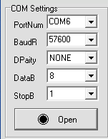
Command list：
Please entry an “Enter” key after each command
Command | Function
SET AUTO OFF | Turn off auto switch function
SET AUTO ON | Turn on auto switch function (Default)
SET RST: | Rest the switch to factory defaults
SET OUT1 VS INy | Set output x to input y (X=1,y=1-4)
SET CAS EN | Set Cascade mode enable (Turn off HDCP)
SET CAS DIS | Set Cascade mode Disable (Turn on HDCP)
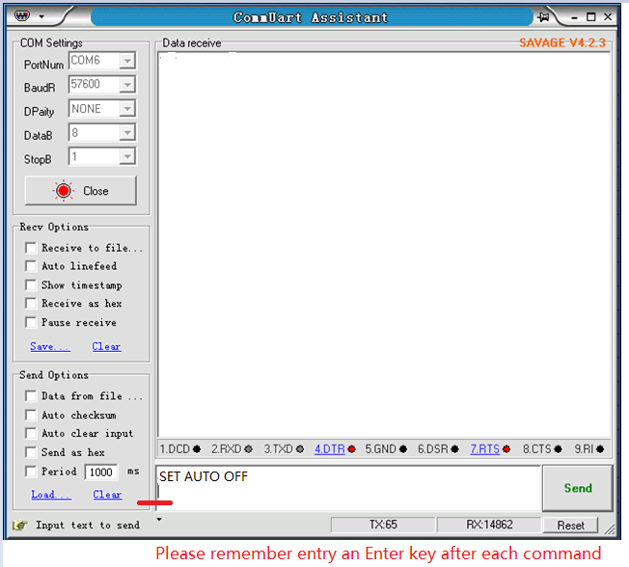

HDCP turn on/off via switch button on the front panel:
- Turn on HDCP (default)
Press and hold down the switch button on the front panel, then power on the switch, keeping hold on the button about 5 seconds, you can see all LEDs intermittent flicker.
It means HDCP is available.
- Turn off HDCP
Press and hold down the switch button on the front panel, then power on the switch, keeping hold on the button about 5 seconds, you can see all LEDs cycle runs in order
It means the HDCP have been removed in this switch.
For more command, please send “H” to get command list.

Upgrade
Baud Rate=57600bps, Data=8bit, Parity=None, Stop=1bit
Double click the UartAssist.exe. Set the correct parameters and click <Open>
Send a command <ISP 32 1> +Enter, then click <Send> button.
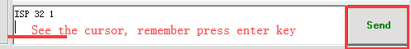
After you sent this command, you will see <JUMP TO ISP MODE...>, and then click <Close>
All LEDs on the switch will be off.
△ DO NOT remove any connection on the switch at this time.
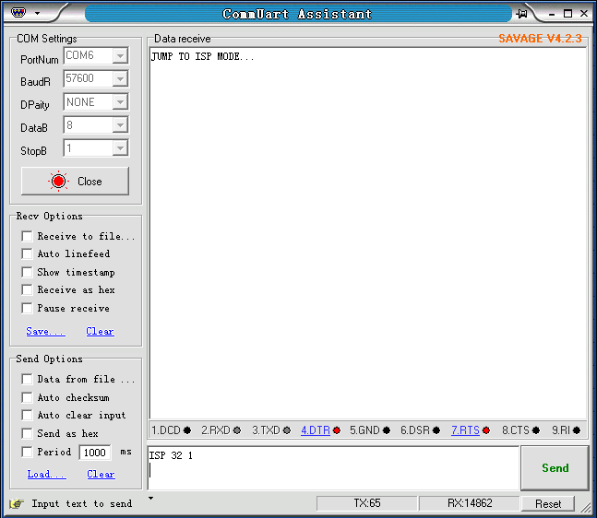
Then, double click the FlyMcu.exe,
Following as below order:
- Search the port
- Select 57600 bps
- Load the .hex file
- Start to ISP (update)
