General Trouble Shooting & Firmware Upgrade Instruction
HDMI 2.0 Matrix 4x2 (EZ-MX42HAS、EZ-MX42PRO-HAS)
Index:
---Initial Installation Checking List
---General Trouble Shooting
Q: How should I do when TV display black screen or "No Signal" message ?
Q: How should I do when picture black, flicker, snow ?
Q: How can I get HDR Dolby Vision picture & Dolby Atmos sound?
Q: How should I do when down-scale 4K, picture blur ?
Q: Does it up-scale 1080p to 4K ?
Q: How do I get DTS/Dolby sound from SPDIF optical port on HDMI Matrix 4x2?
Q: How can I get HDR (HDR10 & Dolby version) picture?
Q: How should I do when video signal drops on the Elgato capture?
---Firmware Upgrade Instruction

- Initial Installation Checking List

- Please connect 4K TV to HDMI Matrix OUT 2 (B) firstly; after 4K TV display well, please connect the second display device to HDMI Matrix OUT 1 (A).
- Please connect 1080p HDMI display to matrix OUT 1(A), especially when 4K & 1080p TV work together.
- When turn off TVs & matrix, please turn on HDMI Matrix OUT 2 (B) 4K TV firstly, especially when 4K & 1080p TV work together.
- HDMI matrix OUT 1(A) down-scale 4K to 1080p, does not support down-scale 4K HDR Dolby Vision. NOT UP SCALER.
- DE-embed SPDIF Optical 5.1CH follows HDMI Matrix OUT 2 (B) , no need TV connection.
- EDID DIP switch TEST MODE can improve compatibility of all HDMI sources.
- Does not support CEC.

- General Trouble shooting
- Q: How should I do when TV display black screen or "No Signal" message ?
A: Please check HDCP setting video.
https://www.youtube.com/watch?v=6aWXT415Zpk

- Q: How should I do when picture black, flicker, snow ?
A: Please make sure HDMI 2.0 cable be qualified up to 18G/bps.
Please exchange HDMI port and devices to verify the issue.
Please press and hold down SCALER button for 5 seconds to reset the matrix (EZ-MX42HAS)
Please press EDID switch button 4 down and up to reset the matrix. (EZ-MX42PRO-HAS)
Also you can try to upgrade firmware via micro-USB port (FW/CTL), please click here to get the tool and guide. Attachment of Firmware Upgrade Instruction for your reference.
https://www.dropbox.com/s/xdbhk38ctvpl0w6/Update%20tools%20kit.rar?dl=0

- Q: How can I get HDR Dolby Vision picture & Dolby Atmos sound?
A: If your HDMI source, display devices support both HDR Dolby Vision & Dolby Atmos, then HDMI Matrix can support both accordingly.

- Q: How should I do when down-scale 4K, picture blur ?
A: Please ensure connect HDMI Matrix OUT 1(A) to down-scale 4K now.
Please ensure down-scale 4K to 1080p only , no another resolution.
Please don` t down-scale 4K HDR Dolby Vision content.

- Q: Does it up-scale 1080p to 4K ?
A: No, it does not support up-scaling.

- Q: How do I get DTS/Dolby sound from SPDIF optical port on HDMI Matrix 4x2?
A:
6-1) Please make sure all the cables are good, and devices power on.
6-2) The SPDIF optical output is following HDMI OUT2 (B), please make sure the device support DTS/Dolby audio is connecting to HDMI OUT2 (B).
6-3) Please make sure your source has been set to Bitstream audio out, different source has different setting.
PS4 PRO: Settings----Sound and Screen----Audio Output Settings
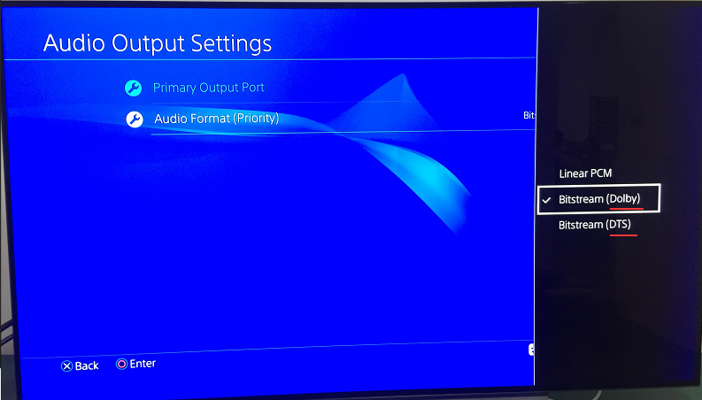
XBox ONE:
Settings----Audio output ----Speaker audio---HDMI audio---Bitstream out
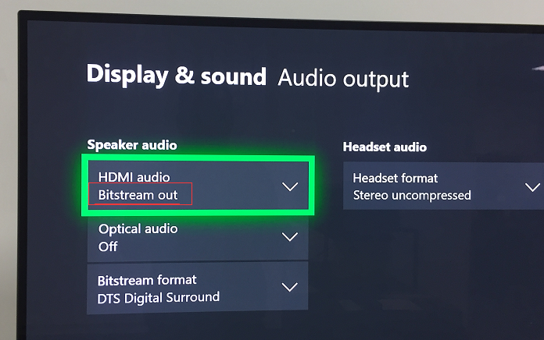
Bitstream format has three options for digital sound
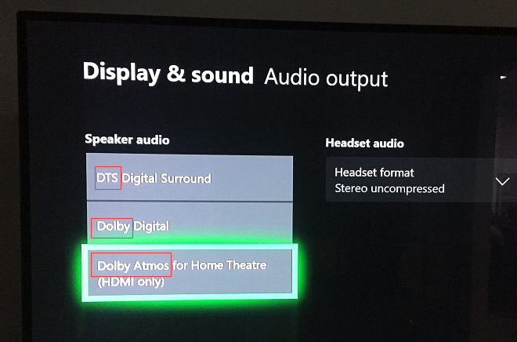

- Q: How can I get HDR (HDR10 & Dolby version) picture?
A:
7-1) Please connect HDMI source to TV directly without matrix, test if TV can support HDMI source HDR. When TV can not display HDMI source HDR info correctly, that means TV issue, not matrix issue.
7-2) Please set HDMI source device HDR feature same as HDMI Matrix HDR after above step testing.
7-3) Please connect HDR display to HDMI OUT2 (B), the matrix will read EDID from OUT2 (B)
7-4) Please make sure the setting in your source is correct. Here is samples for your reference.
PS4 PRO: Settings----Sound and Screen----Video Output Settings
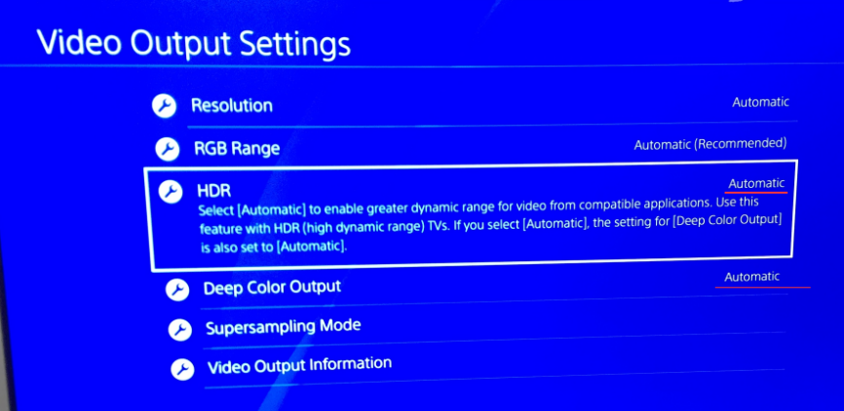

XBox ONE: Settings----Video output ----Display
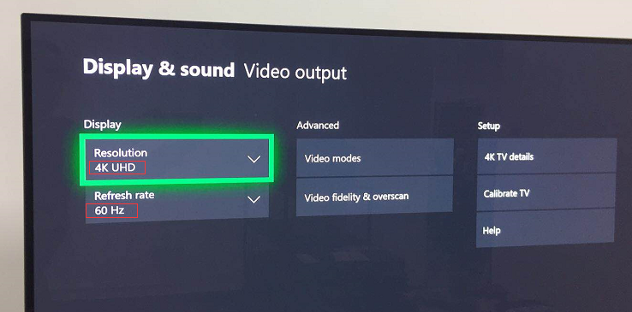
Advanced----Video modes
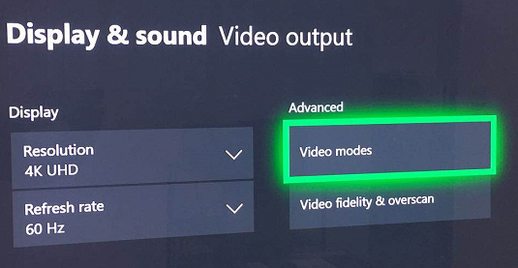
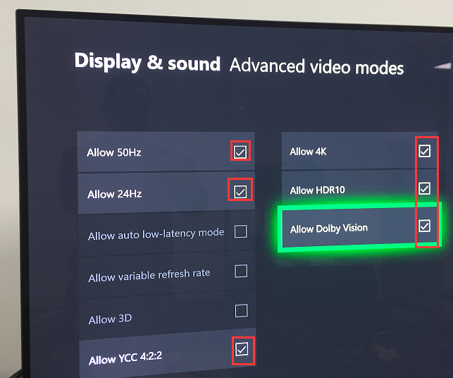

- Q: How should I do when video signal drops on the Elgato capture?
A: Please select TEST MODE via DIP switch to improve the compatibility of HDCP.

- Firmware Upgrade Instruction
Please download Firmware Upgrade Tool via below link, then refer to below Firmware Upgrade Instruction.
https://www.dropbox.com/s/xdbhk38ctvpl0w6/Update%20tools%20kit.rar?dl=0

Baud Rate=57600bps, Data=8bit, Parity=None, Stop=1bit
Double click the UartAssist.exe. Set the correct parameters and click <Open>
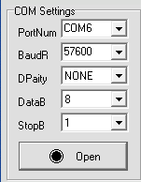
Send a command <ISP 32 1> +Enter, then click <Send> button.
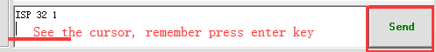
After you sent this command, you will see <JUMP TO ISP MODE...>, and then click <Close>
All LEDs on the matrix will be off.
△ DO NOT remove any connection on the matrix at this time.
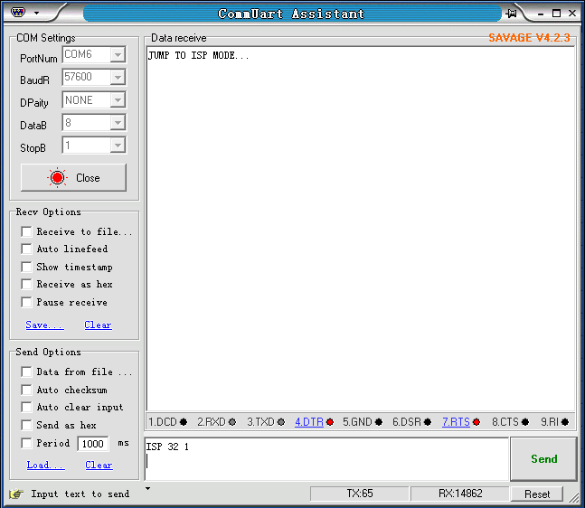
Then, double click the FlyMcu.exe,
Following as below order:
- Search the port
- Select 57600 bps
- Load the .hex file
- Start to ISP (update)
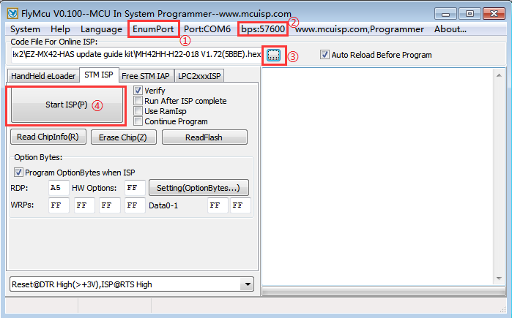
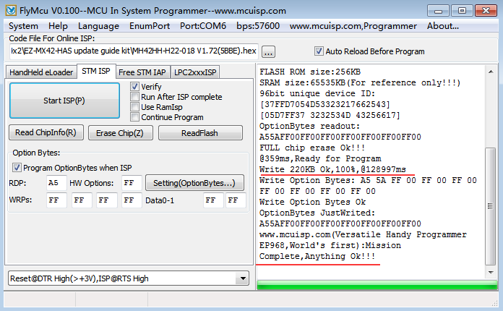

Please contact with us freely ( ezcoo at easycoolav com ) by your private e-mail when you need further assistance.

Thank you for shopping with EZCOO products.

