How to use the Micro-USB on EZCOO product.
We can control the switch and upgrade the switch via USB port.
Please find a Micro-USB cable, connect to the USB port on the front panel to your windows PC(Laptop/Desktop). It will install the driver aromatically when the matrix connected, please wait for a minute..
If you can’t find the device, please find the driver and install by manual.
https://www.easycoolav.com/art/tech-support-a0040.html
Control
Baud Rate=57600bps, Data=8bit, Parity=None, Stop=1bit
Double click the UartAssist.exe. Set the correct parameters and click <Open>
Find the UartAssist.exe at
https://www.easycoolav.com/art/tech-support-a0040.html
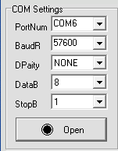

API Command list：
Please entry an “Enter” key after each command
Command | Function
H | Get system help (command list)
SET AUTO OFF | Turn off auto switch function
SET AUTO ON | Turn on auto switch function (Default)
SET RST: | Rest the switch to factory defaults
SET OUT1 VS IN y | Set output x to input y (X=1, y=1-4)
SET CAS EN | Set Cascade mode enable (Turn off HDCP)
SET CAS DIS | Set Cascade mode Disable (Turn on HDCP)
SET IN x EDID y | Set Input x EDID {x= [0~4] (0=ALL), y= [0~32]
EDID List | 0:1080P_2CH ( PCM ) 1:1080P_6CH 2:1080P_8CH 3:1080P_3D_2CH(PCM) 4:1080P_3D_6CH 5:1080P_3D_8CH  6:4K30Hz_3D_2CH ( PCM ) 7:4K30HZ_3D_6CH 8:4K30HZ_3D_8CH 9:4K60Hz(Y420)_3D_2CH(PCM) 10:4K60Hz(Y420)_3D_6CH 11:4K60Hz(Y420)_3D_8CH  12:4K60HZ_3D_2CH 13:4K60HZ_3D_6CH 14:4K60HZ_3D_8CH 15:1080P_2CH(PCM)_HDR 16:1080P_6CH_HDR 17:1080P_8CH_HDR  18:1080P_3D_2CH(PCM)_HDR 19:1080P_3D_6CH_HDR 20:1080P_3D_8CH_HDR 21:4K30Hz_3D_2CH(PCM)_HDR 22:4K30Hz_3D_6CH_HDR 23:4K30Hz_3D_8CH_HDR  24:4K60Hz(Y420)_3D_2CH_HDR 25:4K60Hz(Y420)_3D_6CH_HDR 26:4K60Hz(Y420)_3D_8CH_HDR 27:4K60Hz_3D_2CH(PCM)_HDR 28:4K60Hz_3D_6CH_HDR 29:4K60Hz_3D_8CH_HDR 30:USER1_EDID 31:USER2_EDID 32:USER3_EDID(BY_PASS)
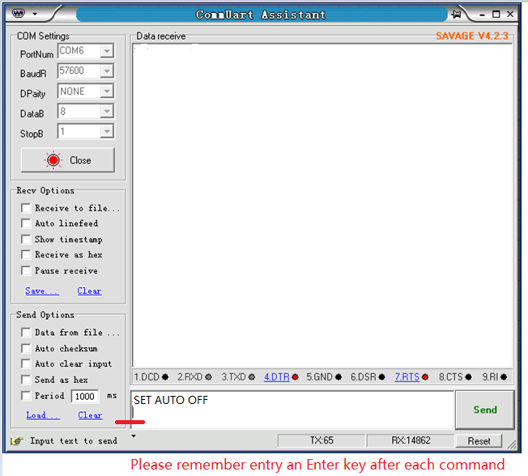

HDCP turn on/off via switch button on the front panel:
- Turn on HDCP (default)
Press and hold down the switch button on the front panel, then power on the switch, keeping hold on the button about 5 seconds, you can see all LEDs intermittent flicker.
It means HDCP is available.
- Turn off HDCP
Press and hold down the switch button on the front panel, then power on the switch, keeping hold on the button about 5 seconds, you can see all LEDs cycle runs in order
It means the HDCP have been removed in this switch.
For more command, please send “H” to get command list.

Upgrade
Baud Rate=57600bps, Data=8bit, Parity=None, Stop=1bit
Double click the UartAssist.exe. Set the correct parameters and click <Open>
Send a command <ISP 32 1> +Enter, then click <Send> button.
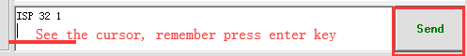
After you sent this command, you will see <JUMP TO ISP MODE...>, and then click <Close>
All LEDs on the switch will be off.
△ DO NOT remove any connection on the switch at this time.
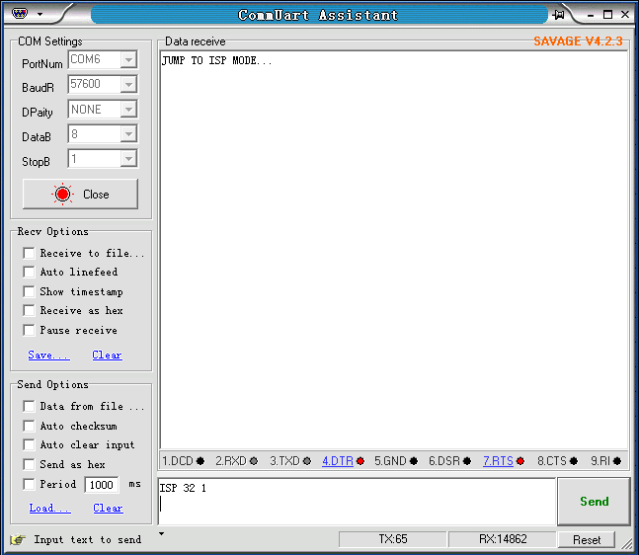
Then, double click the FlyMcu.exe,
Following as below order:
- Search the port
- Select 57600 bps
- Load the .hex file
- Start to ISP (update)
